**Step: 1**

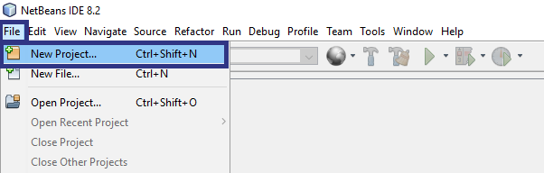

Create new project.

**Step: 2**

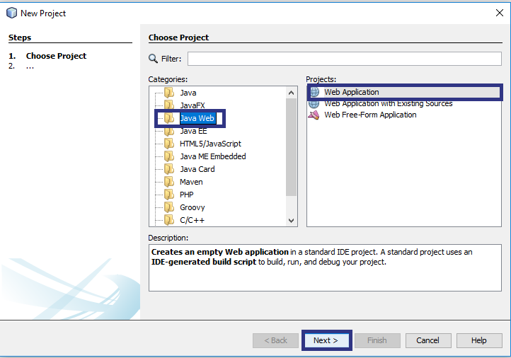

Select project type as java web -> web application.

**Step:3**

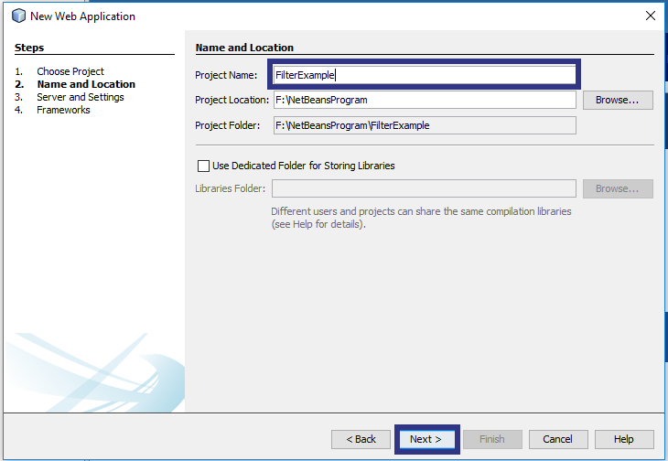

Provide project name

**Step: 4**

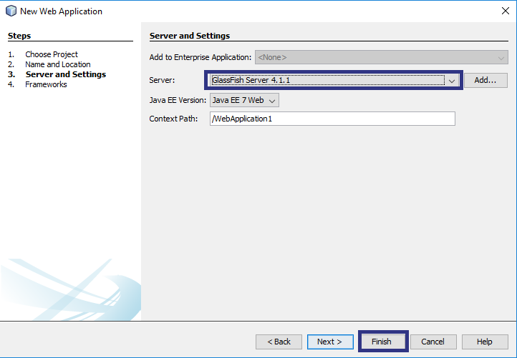

Select server

**Step: 8**

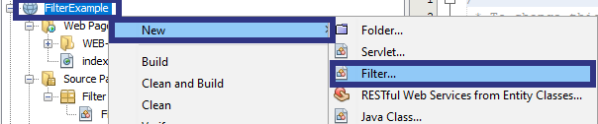

Right click on project and select new filter.

**Step: 9**

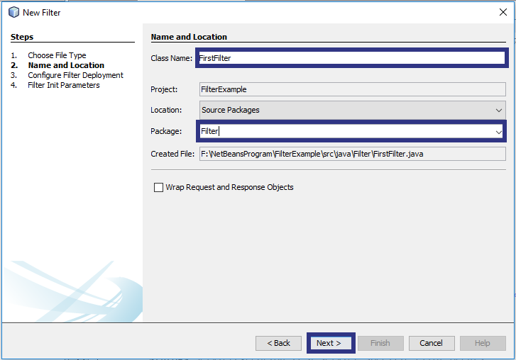

Specify class name and package.

**Step: 9**

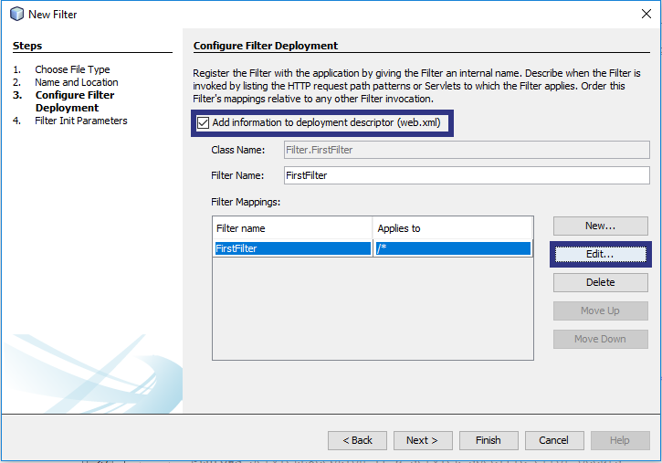

By checking ‘add information to deployment descriptor (web.xml)’ we don’t have to write any code for mapping of filter by our self.

**Step: 10**

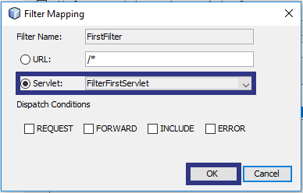

by editing filter mapping we can edit url or servlet to which filter is mapped.